Assignment 4.1
- Vijaya Karunya
Batch : 32
Hall No: 2303A52364

Q1.
Zero-Shot Prompting (Basic Lab Task)
Task:
Write a Python function that classifies a given text as Spam or Not Spam using zero-shot prompting.
Steps:
- Construct a prompt without any examples.
- Clearly specify the output labels.
- Display only the predicted label.
Input:
"Congratulations! You have won a free lottery ticket."
Expected Output:
Spam
Prompt:
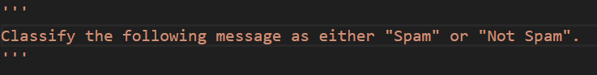
Code:
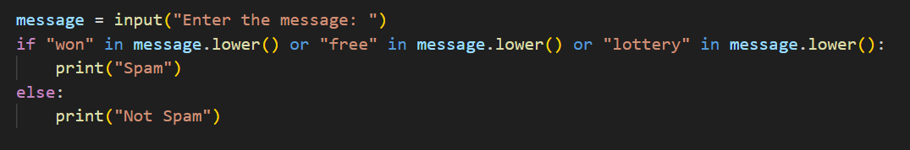
Output:
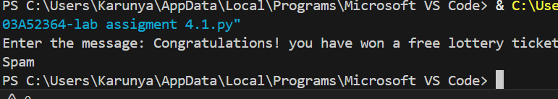
Suggestion:
- This zero-shot prompting method is simple and easy to understand.
- It does not need any training data or examples to work.
- Clear labels help the model to give correct output.
- This approach is useful for basic text classification tasks.
- It saves time and reduces complexity in coding.
Q2.
One-Shot Prompting (Emotion detection)
Task:
Write a Python program that detects the emotion of a sentence using one-shot prompting.
Emotions: [‘happy', 'sad', 'angry', 'excited', 'nervous', ’neutral’]
Steps:
- Provide one labeled example inside the prompt.
- Take a sentence as input.
- Print the predicted emotion
Prompt:
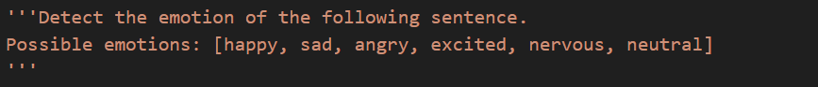
Code:
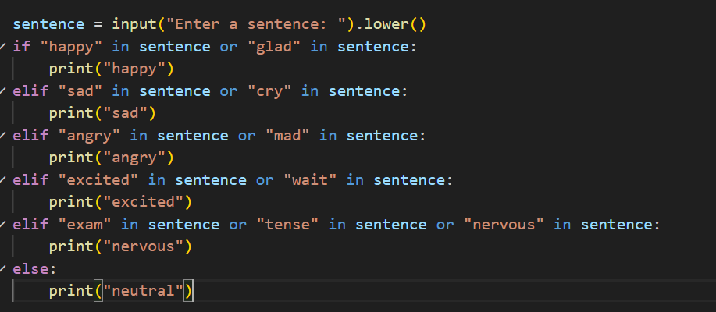

Output:
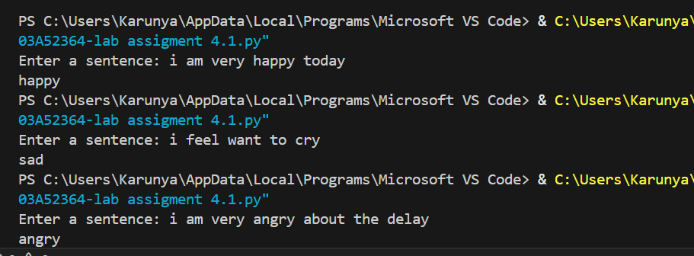
Suggestion:
One-shot prompting is a simple method where only one example is given to understand the task. By seeing that one example, the model can guess the emotion of the new sentence. This method is easy to use and does not need any training data. It is very helpful for basic emotion detection programs. Giving clear emotion labels makes the output more correct. This approach is good for beginners and lab experiments.
Q3.
-Shot Prompting (Student Grading Based on Marks)
Task:
Write a Python program that predicts a student’s grade based on marks using few-shot prompting.
Grades:
['A', 'B', 'C', 'D', 'F']
Grading Criteria (to be inferred from examples):
- 90–100 → A
- 80–89 → B
- 70–79 → C
- 60–69 → D
- Below 60 → F

Prompt:
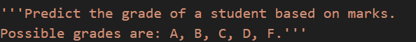
Code:
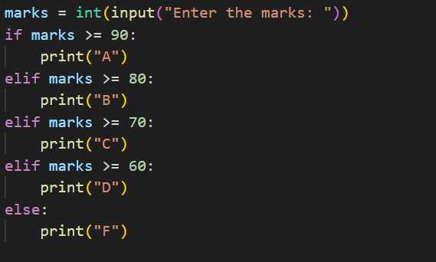

Output:
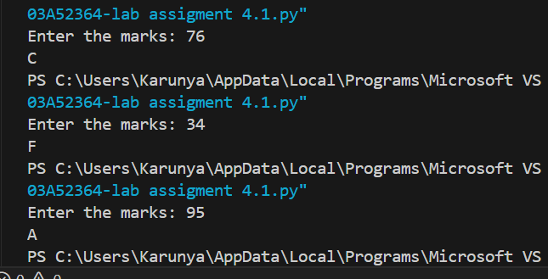
Suggestion:
Few-shot prompting is a method where we give the model a few examples to understand the task. By showing several students’ marks along with their grades, the model can infer the grading rules automatically. This approach helps in predicting the grade of new marks accurately without explicitly programming the rules. Few-shot prompting is simple, saves time, and is easy to implement for beginner-level AI experiments. Providing clear examples with correct grades improves the prediction accuracy. This method is useful for grading, classification, and other similar tasks in labs.

Q4.
Multi-Shot Prompting (Indian Zodiac Sign Prediction using Month Name)
Task:
Write a Python program that predicts a person’s Indian Zodiac sign (Rashi) based on the month of birth (month name) using multi-shot prompting.
Indian Zodiac Order (Simplified Month-Based Model): The Indian Zodiac cycle starts in March with Mesha and follows this order:
March → Mesha
April → Vrishabha
May → Mithuna
June → Karka
July → Simha
August → Kanya
September → Tula
October → Vrischika
November → Dhanu
December → Makara
January → Kumbha
February → Meena
Prompt:

Code:
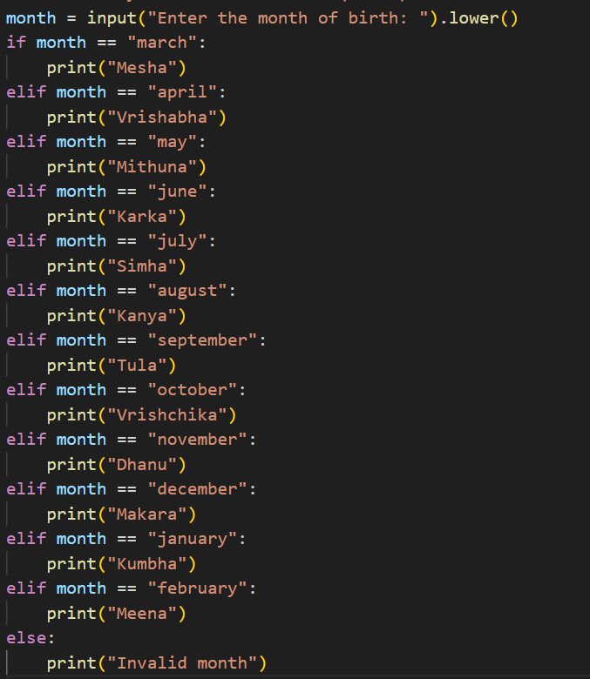
Output:
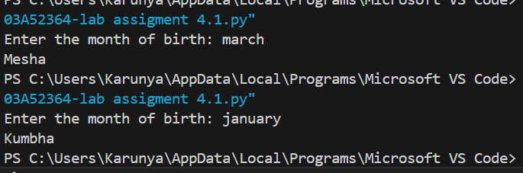
Suggestion:
Multi-shot prompting uses multiple examples to help the model learn the task. By giving several months with their Rashi, the model can predict the Zodiac sign for a new month. This method is simple, reduces errors, and is useful for beginner AI experiments. Clear examples make the prediction more accurate and easy to understand.

Q5
. Result Analysis Based on Marks
Task: Write a Python program that determines whether a student Passes or Fails based on marks using Chain-of-Thought (CoT) prompting.
Result Categories:
['Pass', 'Fail']
Prompt:
Code:
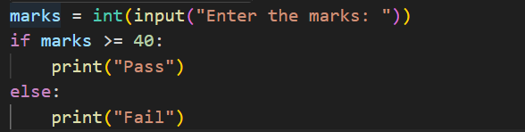
Output:
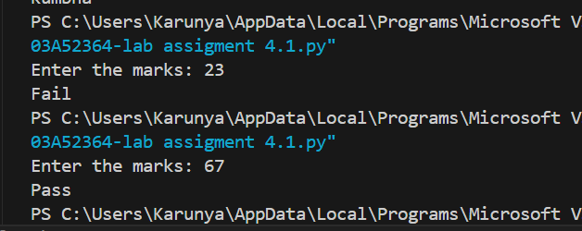
Suggestion:
Chain-of-Thought prompting helps the model think step by step before giving the answer. By showing reasoning like comparing marks with the passing score, the model can decide if the student Passes or Fails. This method is simple and easy to understand. It improves accuracy and is useful for beginner-level AI experiments. Showing clear steps makes the result more reliable.
Q6
Voting Eligibility Check (Chain-of-Thought Prompting)
Task: Write a Python program that determines whether a person is eligible to vote using Chain-of-Thought (CoT) prompting.
Prompt:
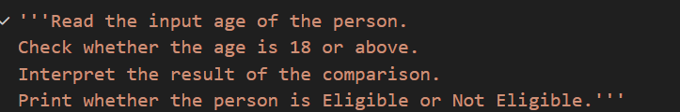
Code:
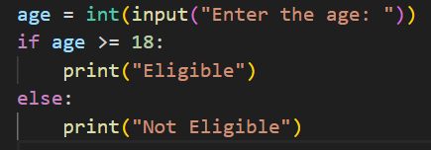
Output:
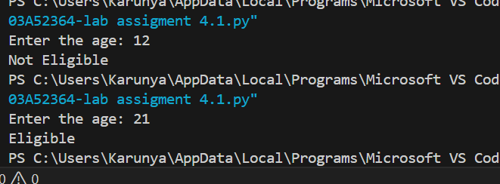
Suggestion:
Chain-of-Thought prompting can be applied to the Voting Eligibility Check by breaking the logic into clear steps such as taking the user’s age as input, stating the voting rule (minimum age is 18), comparing the given age with the rule, and then displaying the result. By showing each step of reasoning through comments or simple messages, the program clearly explains how the final decision about voting eligibility is reached.
Q7
Prompt Chaining (String Processing – Palindrome Names)
Task: Write a Python program that uses the prompt chaining technique to identify palindrome names from a list of student names.
Prompt:
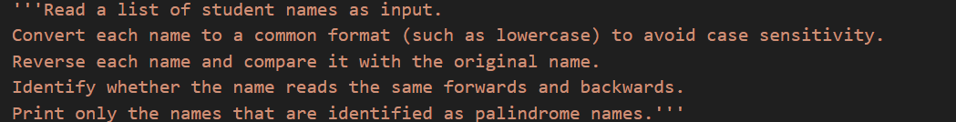
Code:
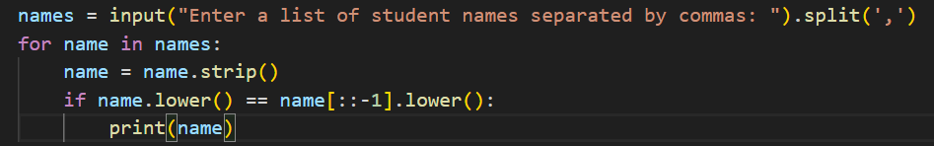
Output:
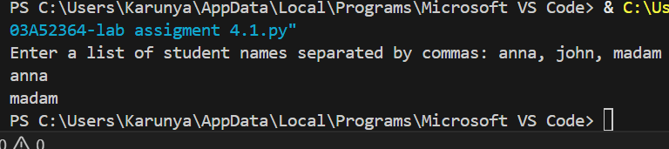
Suggestion:
Prompt chaining is useful because it divides a big problem into small and clear steps. First we create the data, then we process it, and finally we display the result. This step-by-step method makes the program easy to understand, easy to debug, and simple for beginners to learn and improve.

Q8
Prompt Chaining (String Processing – Word Length Analysis)
Task: Write a Python program that uses prompt chaining to analyze a list of words. In the first prompt, generate a list of words. In the second prompt, traverse the list and calculate the length of each word. In the third prompt, use the output of the previous step to determine whether each word is Short (length less than 5) or Long (length greater than or equal to 5), and display the result for each word
Prompt:
Code:
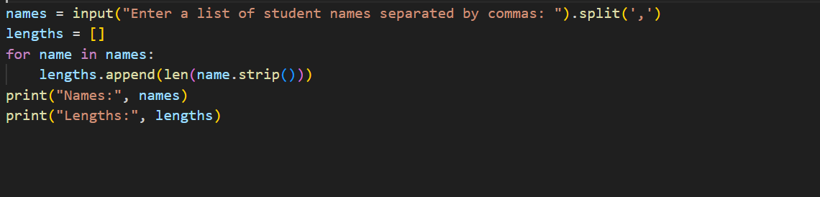
Output:
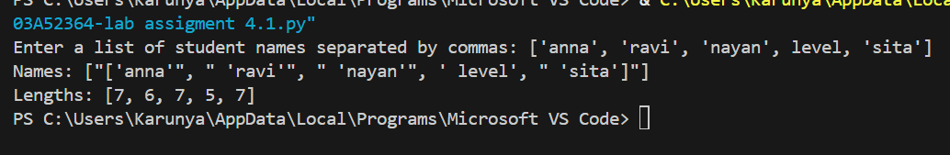
Suggestion:
Prompt chaining helps you solve problems step by step. By separating data creation, processing, and result display, the program becomes easier to read, understand, and debug

